Institute of Computer Technology

B. Tech Computer Science and Engineering

Subject: DS (2CSE302)

**PRACTICAL-2**

**AIM: - To learn about Deletion, Searching and Updating an element in an array.**

* **As per the previous database(Practical-1.2), Manish is having database which considers record for 7 days. He has done some mistake in record, so he needs to do some changes. Kindly refer given tasks and implement C code using following steps (Make Suitable Assumptions):**

**1. He needs to delete record of day 3 from his previous records.**

***SOLUTION***

#include <stdio.h>

int main()

{

int Day[]={45,42,39,40,54,41,48};

int Loc=3, n=7,i,j;

j=Loc;

printf("\nBefore Deleting:-\n");

for(int i=0;i<n;i++)

{

printf("Day %d: %d\n",i+1,Day[i]);

}

while(j<n)

{

Day[j-1]=Day[j];

j=j+1;

}

n=n-1;

printf("\nAfter Deleting:-\n");

for(int i=0;i<n;i++)

{

printf("Day %d: %d\n",i+1,Day[i]);

}

return 0;

}

***OUTPUT***

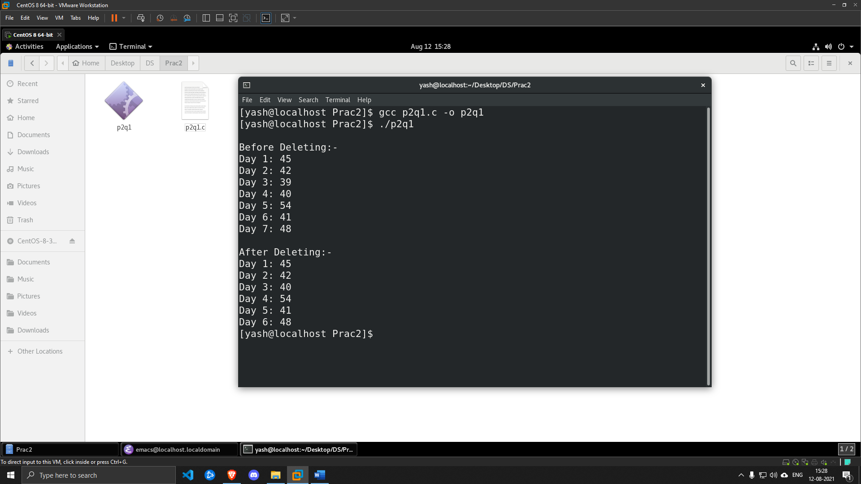

**2. Manager asked to Manish that when he did 41 calls, however Manish forgot that at which day he has done 41 calls. So needs to search that at which day he has done 41 calls from the record.**

***SOLUTION***

#include <stdio.h>

int main()

{

int Day[]={45,42,40,54,41,48};

int search=41, n=6;

int j=0;

while(j<n)

{

if(Day[j]==search)

{

break;

}

j++;

}

printf("\nResult of search is at day %d=%d\n\n",j,Day[j]);

return 0;

}

***OUTPUT***

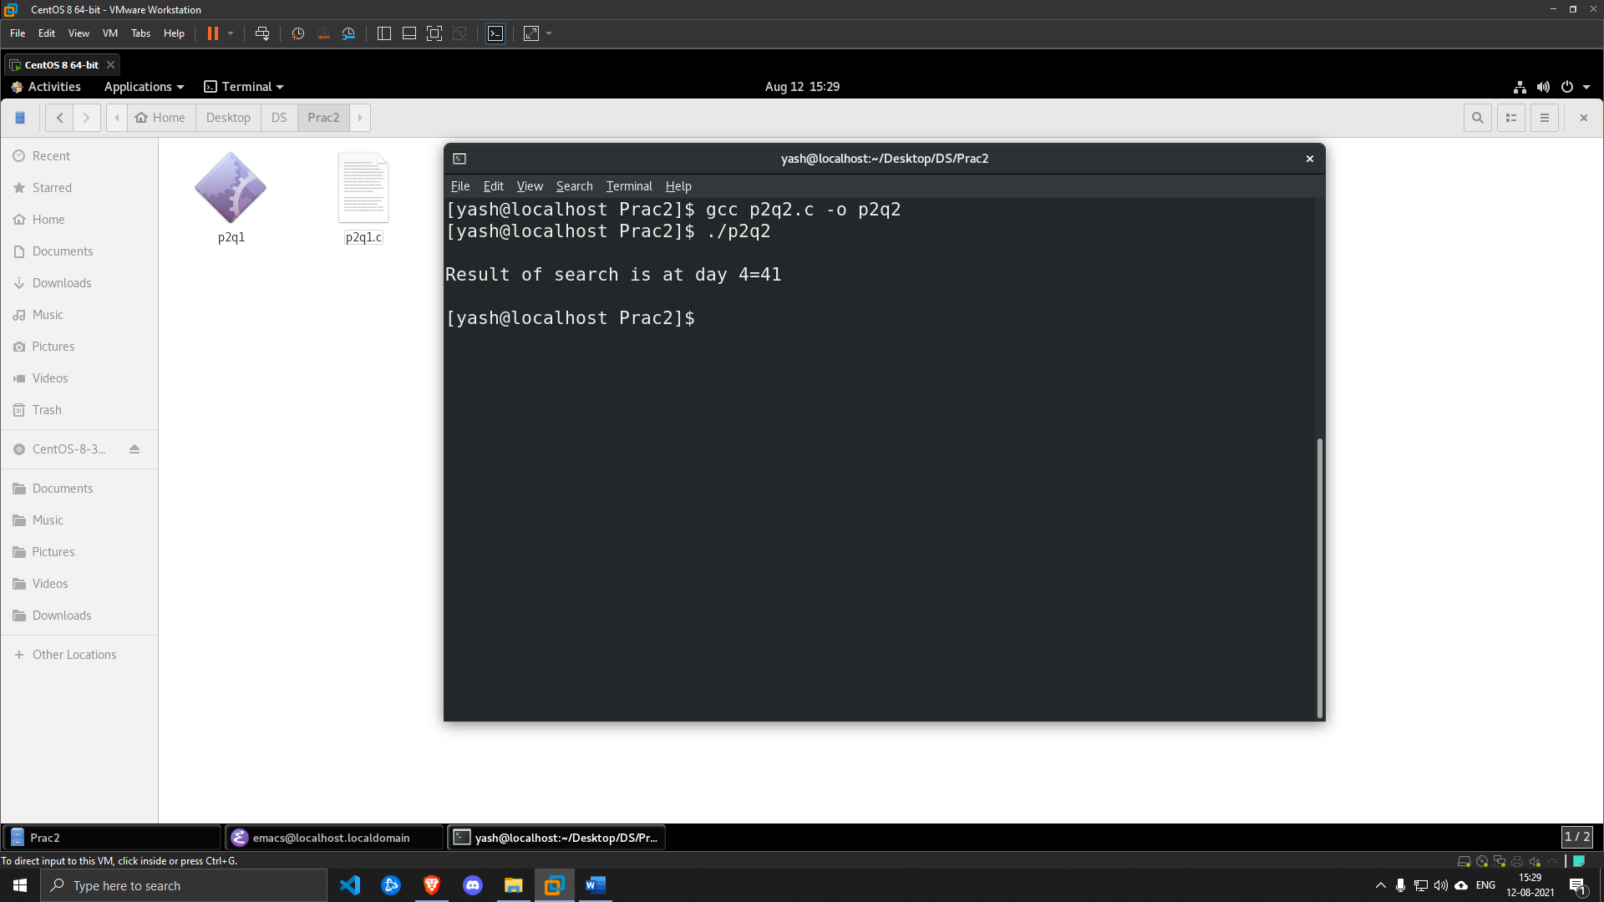

**3. Actually Manish did 46 calls at day-3 but he has written 40 calls, so needs to update day 3 calls with 46.**

***SOLUTION***

#include <stdio.h>

int main()

{

int Day[]={45,42,40,54,41,48};

int replace=40, n=6;

int j=0;

printf("\nBefore Replacing: -\n");

for(int i=0;i<n;i++)

{

printf("Day %d: %d\n",i+1,Day[i]);

}

while(j<n)

{

if(Day[j]==replace)

{

Day[j]=46;

}

j++;

}

printf("\nAfter Replacing: -\n");

for(int i=0;i<n;i++)

{

printf("Day %d: %d\n",i+1,Day[i]);

}

return 0;

}

***OUTPUT***

